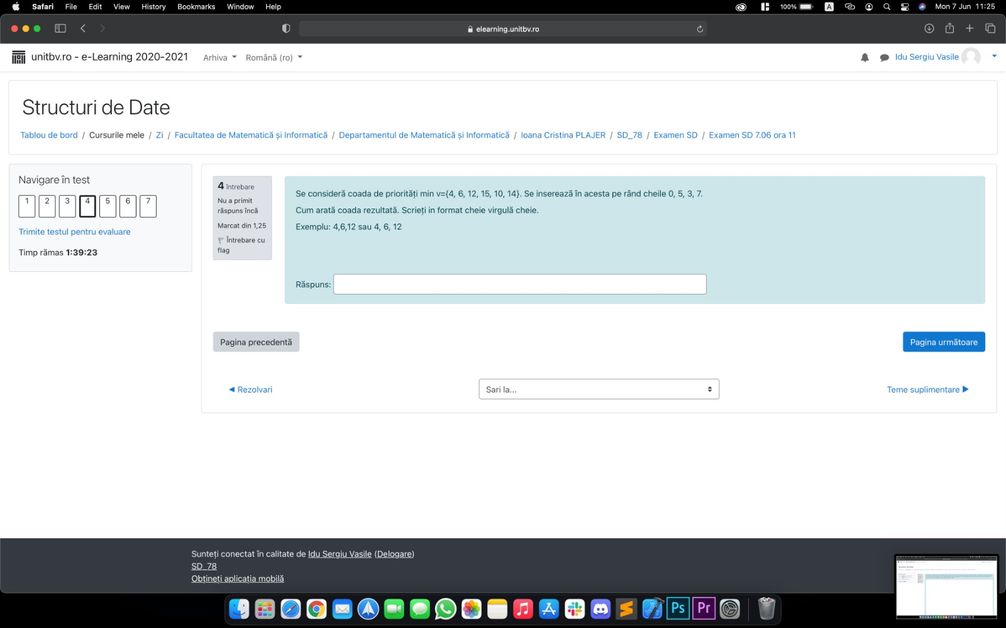

**RASPUNS:** 0,3,4,5,7,14,12,15,6,10

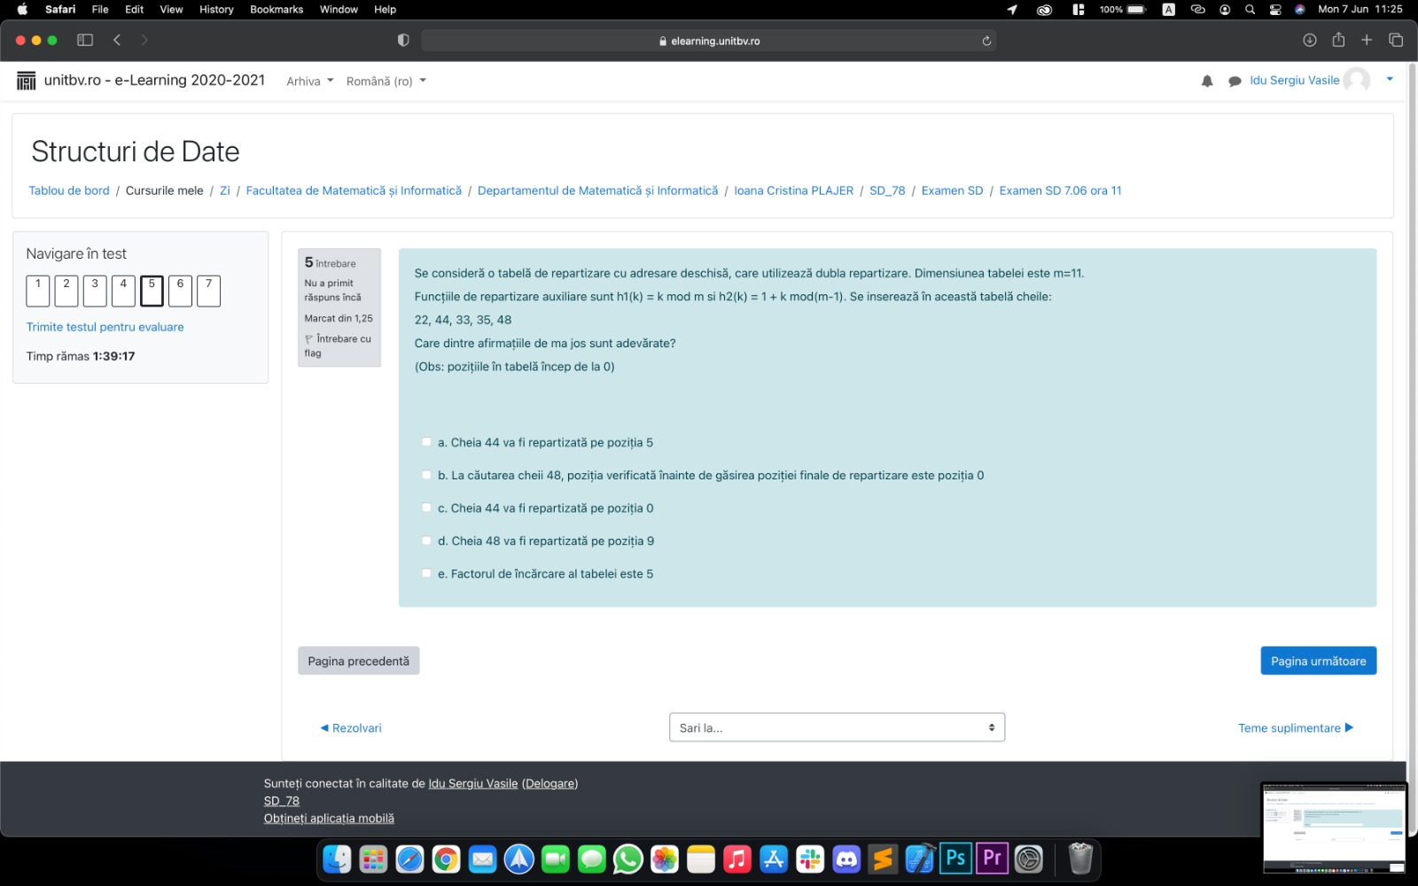

Tabela: 22,nil,35, nil, 33,44, nil, nil,nil, 48,nil

**RASPUNS:** a,b,d

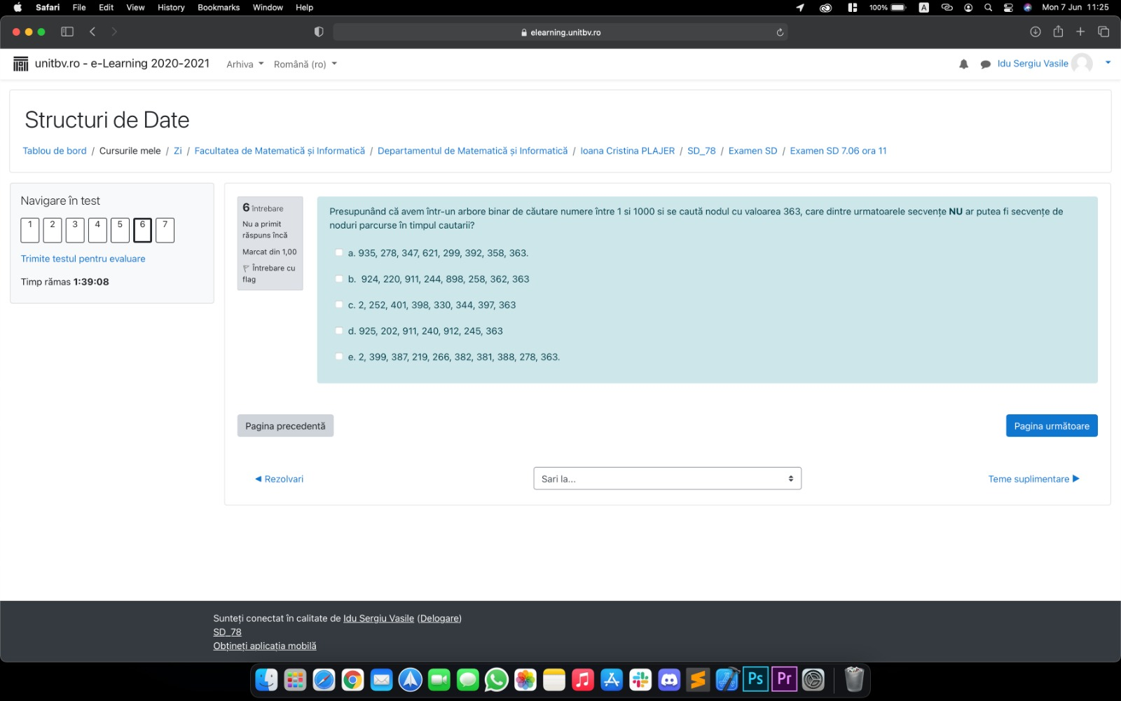

**RASPUNS:** a,d,e

